**Custom ISO image creation**

Step 1: - Install cubic by run these commands in terminal-

$ apt-add-repository ppa:cubic-wizard/release

$ apt update

$ apt install cubic

Step 2: - Download the ubuntu 22.04 iso from the below link.

<https://ubuntu.com/download/desktop/thank-you?version=22.04.2&architecture=amd64>

Step3: - Open cubic and create a folder where cubic can be used as working directory.

Select the directory location & after that click on next button.

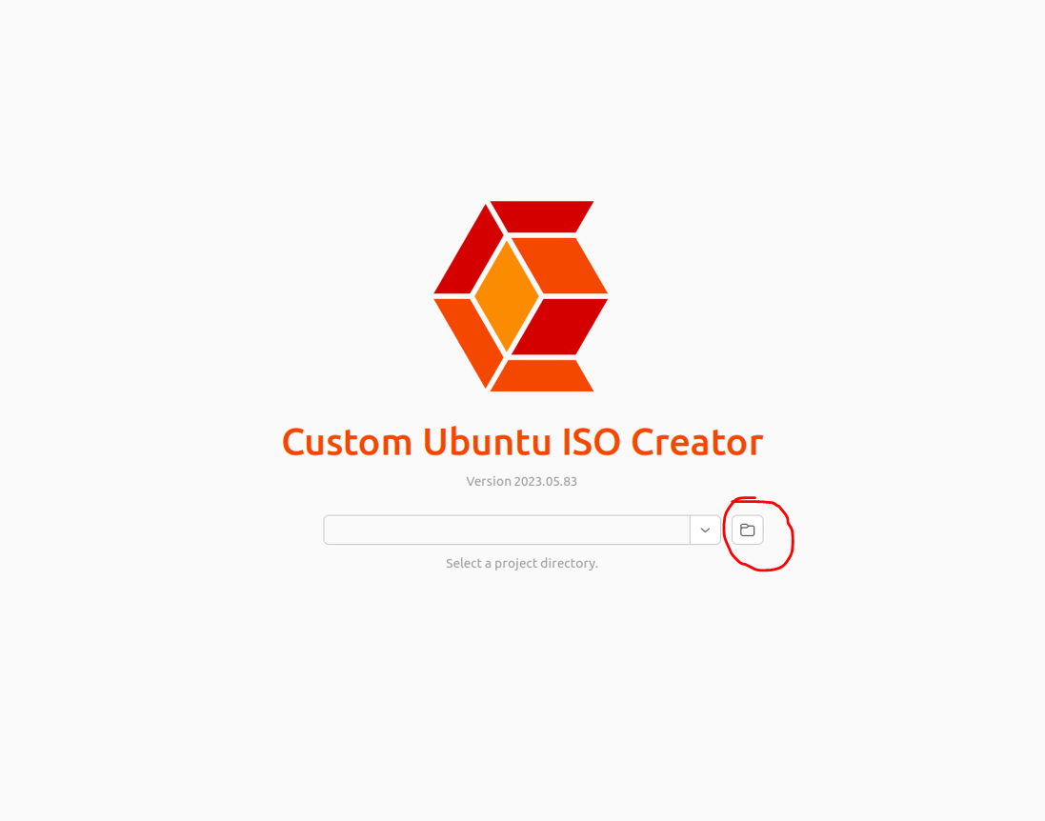

Step 4: -Select the location of base ubuntu 22.04 image & click on next.

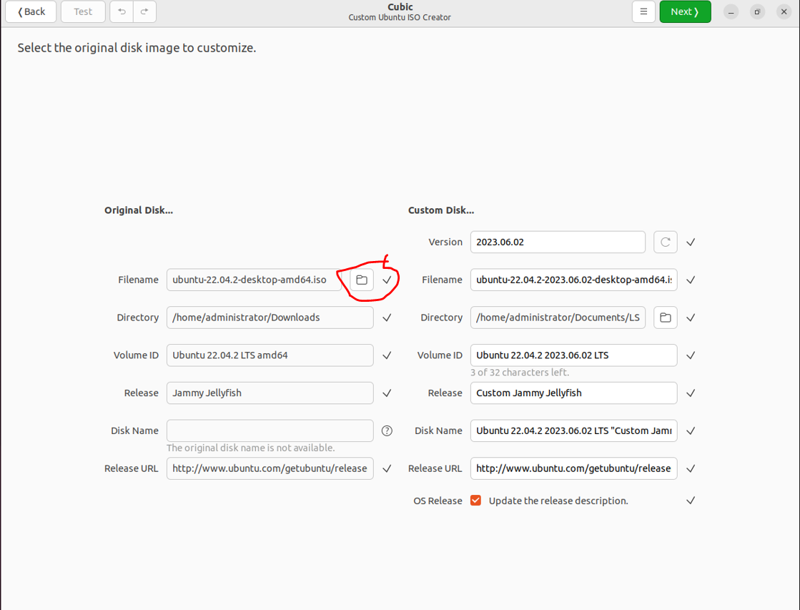

Step 5: - Now enter in virtual environment root mode there we can customize iso.

**NOTE**-: Copy and paste the files directly and text on root.

In cubic root virtual env->

1. Create a directory

Run these commands:

$ mkdir /hexwave

$ cd /hexwave

* copy the bootstrap.sh
* copy hexwave-package
* copy hexwave_key_repo.json
* copy shell script run_hexwave_install.sh

#!/bin/bash

# Define the path to the boot count file

boot_count_file=/.boot_count

# Check if the boot count file exists

if [ -f "$boot_count_file" ]; then

boot_count=$(cat "$boot_count_file")

boot_count=$((boot_count+1))

echo "$boot_count" > "$boot_count_file"

if [ "$boot_count" -eq 2 ]; then

echo "Installtion of hexwave"

sudo dpkg -i /hexwave/hexwave-package-0.0.1.deb

sudo cp /hexwave/hexwave_repo_key.json /data/config

sudo /opt/hexwave/bin/init_pipeline.sh

fi

else

echo "1" > "$boot_count_file"

fi

* Give executable permissions using command
* chmod +x bootstrap.sh
* chmod +x hexwave_key_repo.json
* chmod +x run_hexwave_install.sh

1. Now create a crontab job by run the command:

$ crontab -e

* Choose nano editor
* Write below text in crontab

@reboot /bin/bash -c "/hexwave/bootstrap.sh >> /logfile_bootstrap.log 2>&1 && (crontab -l | grep -v '/hexwave/bootstrap.sh' | crontab -)"

@reboot /hexwave/run_hexwave_install.sh >> /logfile_hexwave_install.log 2>&1`

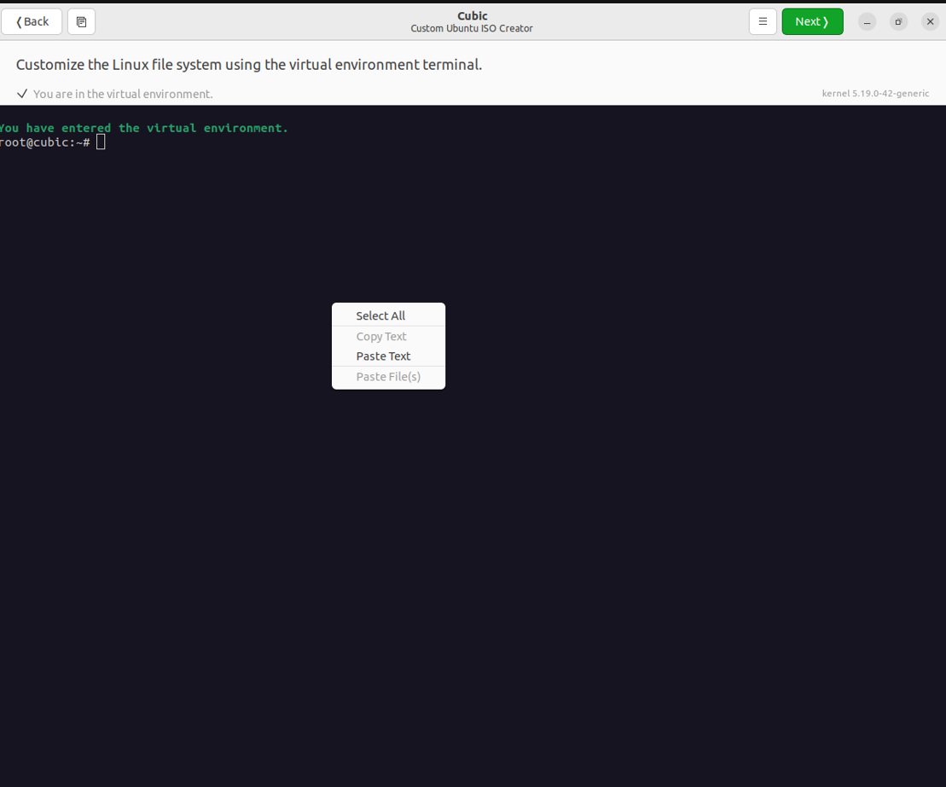

After customization click on next.

Step 6: -Go ahead with default setting & click on next.

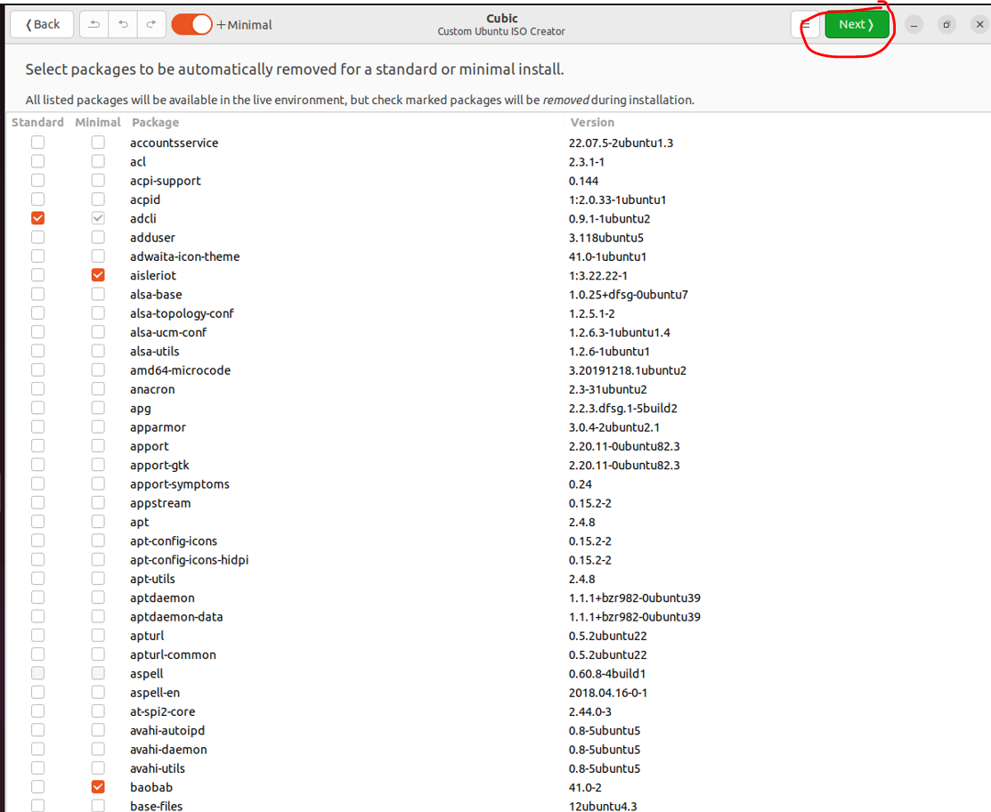

Step 7: -Click on Preseed & write the ubuntu.seed file

To get ubuntu.seed click on the below icon to get file & click on next.



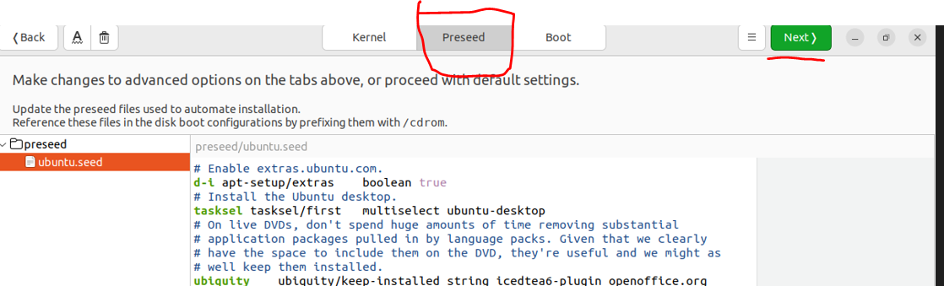

Step 8: -Click on generate

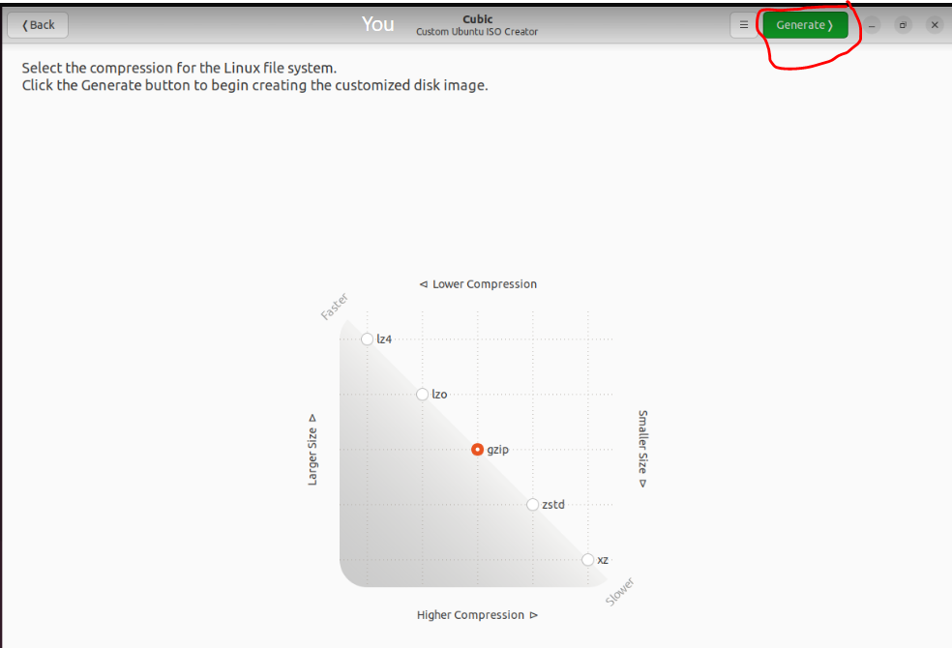

Step 9:- After generating , iso creation is completed. It will be showing like this .

In cubic working directory, we can show custom image.

